
Data Security Learning
outcome 4-Final Report
A report for KisekiWorld

May 29, 2026
Submitted By: Biki Maharjan
Submitted to: Richard Copeland

Contents
Background: 2
Potential Breaches: 2
Security Strategy: 2
Legislation & Consequences: 3
1. Data Protection Act 2018 and UK GDPR 3
2. Computer Misuse Act 1990 3
3. Privacy and Electronic Communications Regulations 2003 3
References 4
Screenshots: 4

Background:
KisekiWorld is a recently released online role-playing game. Players are transported to an alternative reality, where they can choose an avatar and dress it in different outfits. The player’s character then commences on various quests such as building houses, seeking out treasure, collecting assets, defeating enemies and forging alliances with other characters. The game is proving to be very popular and has already attracted a substantial following. It is promoted through various social media sites.
Because the game is linked to social media login information, security is paramount as a breach of the game’s login server information may also facilitate a breach of the social media site, and vice versa. In addition, the game offers the opportunity to buy various extra items or circumvent hurdles by the means of in-game purchases, either by an online payment facility or by credit or debit card. As KisekiWorld’s servers will hold payment information, this data has to be securely protected. Although the company have offices and servers in the UK, their players are resident in countries all over the world, a substantial proportion of them being registered in the EU.

Potential Breaches:
KisekiWorld uses social media login information and access to user accounts could be gained using phishing attacks or brute force attacks in case of weak password which can lead to leak of user data and financial credentials as well if the user has saved it in the game. In addition to that, the chance of hackers using Man in the Middle Attacks is also possible in case the network in the system and user device is not encrypted and proper firewall and network screening is not done.
Since it is an online multiplayer game and will have large player database, the perpetrators can possibly attack using DDOS attack and create huge traffic in the game which would disrupt the game completely. This could result in loss of revenue and would degrade the reputation of the game. An insider threat, an employee from the KisekiWorld, could access sensitive data without authorisation and misuse or leak them intentionally or accidentally.
Social Engineering is another way a perpetrator could gain access to the network or even physical devices inside the organisation using social or psychological manipulation. An attacker acting as an employee or a delivery guy could use the opportunity when another employee is opening the door. This could be used to gain access to the system remotely or physically.

Security Strategy:
First, strong login credential guidance for users should be provided like using numbers and special signs along with uppercase and lowercase combinations like 1ns0mn1@c$$#432@45&^. A multifactor authentication will add extra security layer which would ensure the user is genuine. A perpetrator might hack into the email id but the chance of getting OTC got in the phone by hacker is slim at the same time.
Conducting penetration testing frequently and scanning the network regularly will be beneficial to finding any weak parts in the system and patching such vulnerabilities will prevent from hackers gaining access to the network. Proper firewall like pfSense, Windows defender would aid some prevention in the MITM and DDOS attacks. This could also be done by adding physical firewall devices and encrypting data, so the data is secured event the system is compromised. Intrusion Detection System are handy in monitoring the traffic in the system flagging any unusual activity in the network and system.
One of the most important security measures would be training the user and employee about company policy, cyber issues and social engineering techniques such as pretexting, phishing, tailgating, baiting, etc. This would provide a sense of understanding on what is acceptable in the company and consequences in relation to failing to comply with company policies as well as prevent falling victim to social engineering attacks.
Physical security to the organisation is vital as well. Access to the physical devices in the organization would mean direct access to all the information in the database which would compromise all the personal user data, financial data along with company data and financial credentials. The building must be secured using security measures like fencing, CCTV, guards and authorisation using biometrics and ID cards. Frequent backups is a must in case of emergency situations or an attack.

Legislation & Consequences:
KisekiWorld is a UK based company and must follow UK legislation and since it has many EU players it must comply with laws that are prevalent in Europe and globally in case of players around the world. Some of the must legislation they must follow but not limited to are:

Data Protection Act 2018 and UK GDPR
Under Data Protection Act 2018 and UK GDPR, KisekiWorld must ensure all user data is processed and secured lawfully, fairly and transparently for specific legitimate purposes. The organisation must make sure that the user’s right to access or erase the data is respected.
The UK GDPR and DPA work together to regulate data protection and privacy.
Failing to comply with the Data Protection Act 2018 and GDPR can result in financial penalties, criminal liability along with loss of trust in the organisation.

Computer Misuse Act 1990
KisekiWorld are responsible for protecting the game servers and infrastructure, player accounts and their personal and financial data. The Computer Misuse Act 1990 makes it illegal to access computer systems without permission intentionally or accidentally, steal or misuse data, damage systems, or create hacking tools. The law helps KisekiWorld protect players from hackers through legal actions. KisekiWorld would be safe if in compliance with Computer Misuse Act or else could face financial loss, reputational damage or possible legal investigations.

Privacy and Electronic Communications Regulations 2003
Privacy and Electronic Communications Regulations 2003 deals with protection of user’s privacy and electronic communications such as emails and cookies. KisekiWorld is linked to social media and therefore is liable under the act to make sure users consent before using cookies and any marketing emails or notifications must be opted in by the user to receive them. Plus, personal and sensitive user data must be kept secure during online communication.
The consequences of not complying with PECR 2003 may result to fines and legal action along with reputational damage.
More details on European and global data protection act needs to be researched and global cyber ethics should be followed so that no harm can come to the users, organizations and their data.

References
Sampy, R., 2025. Skillcast. [Online]
Available at: https://www.skillcast.com/blog/data-protection-act-2018
[Accessed 29 05 2026].

Screenshots:
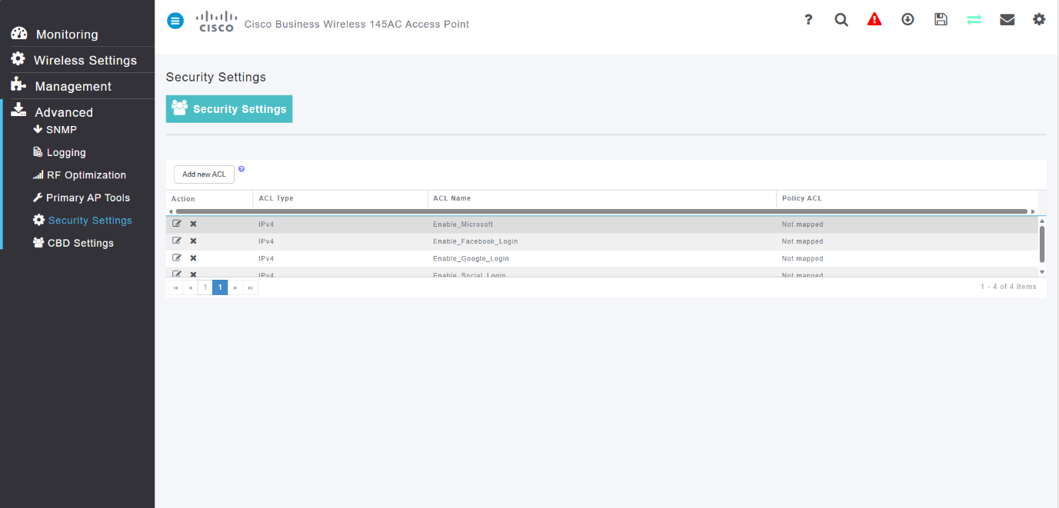

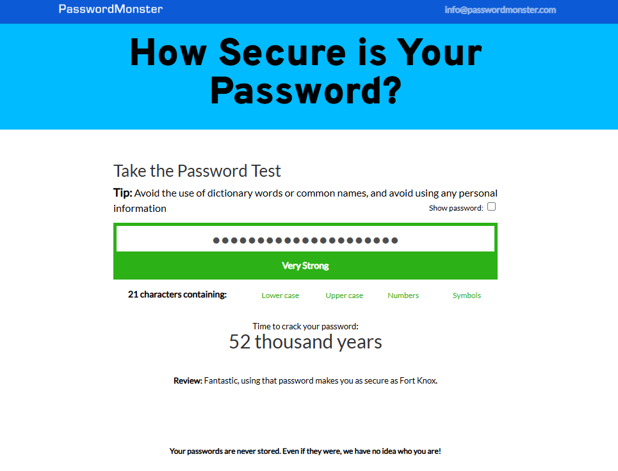
Figure 1.1 Use of firewall to deny access to unwanted traffic
Figure 1.2 Password Test
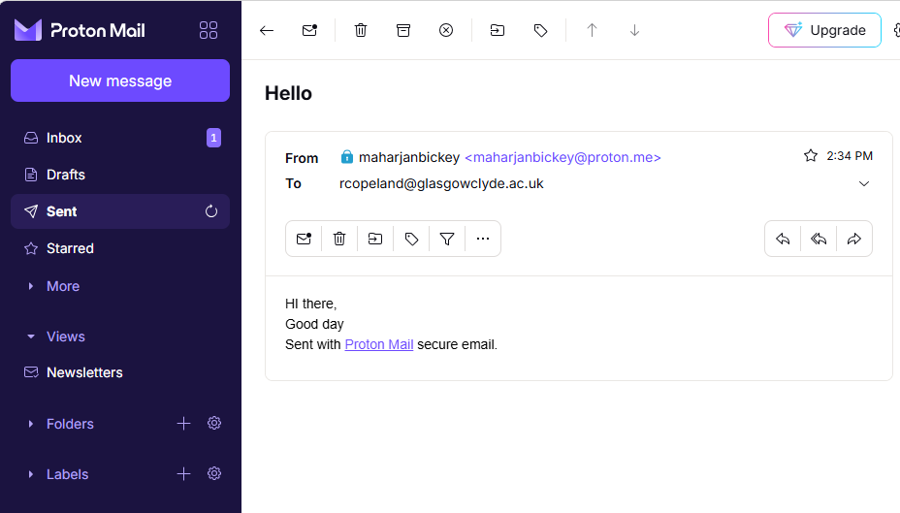
Figure 1.3 Encrypted email

